**Searching Functionality Demo:-**

1. **For Quick Search:-**

If you entered keyword of product name, then all related product will be shown according to keyword.

For example: - According to keyword ‘a’

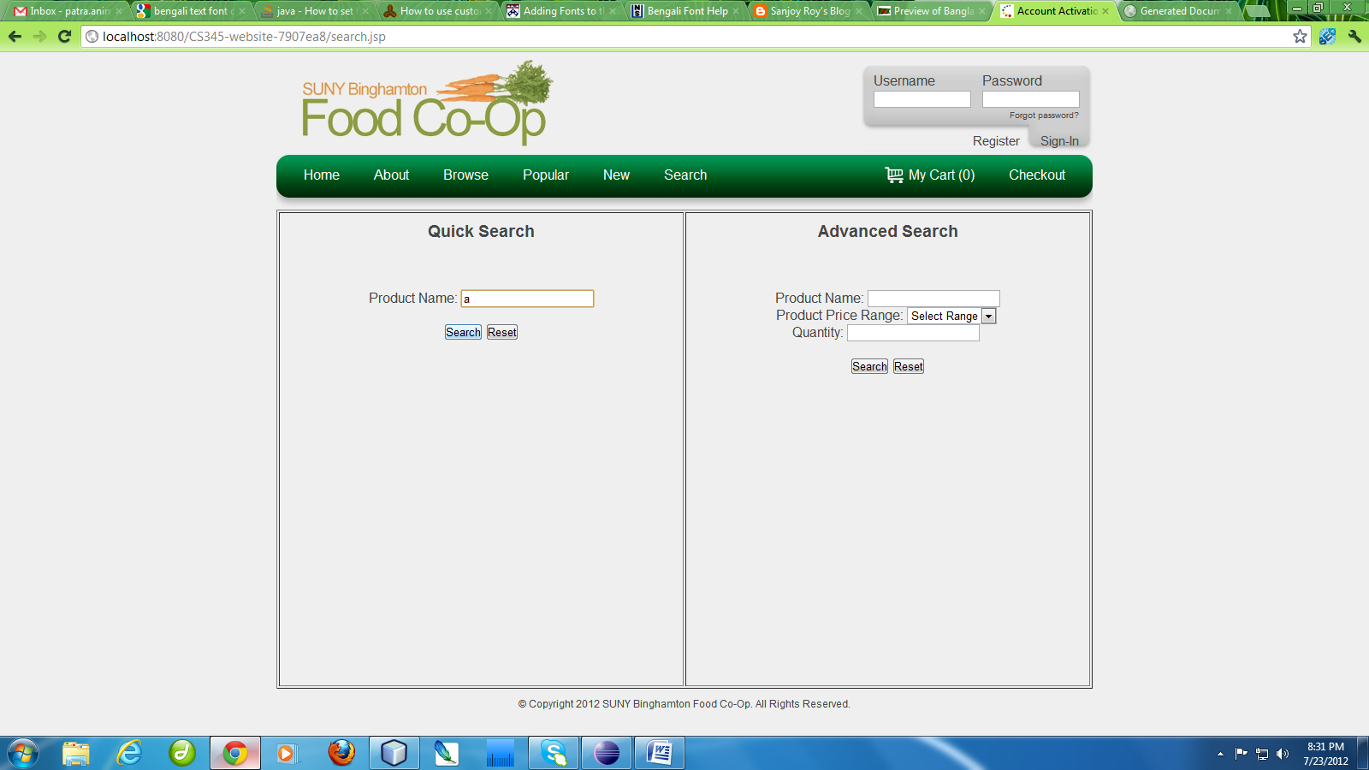

Product shown which have keyword ‘a’

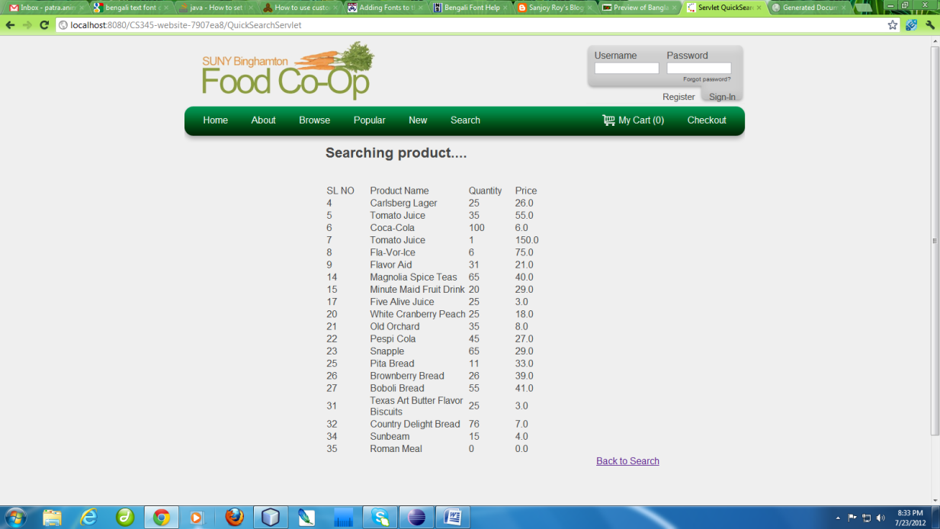

Similarly when we enter keyword ‘Bread’

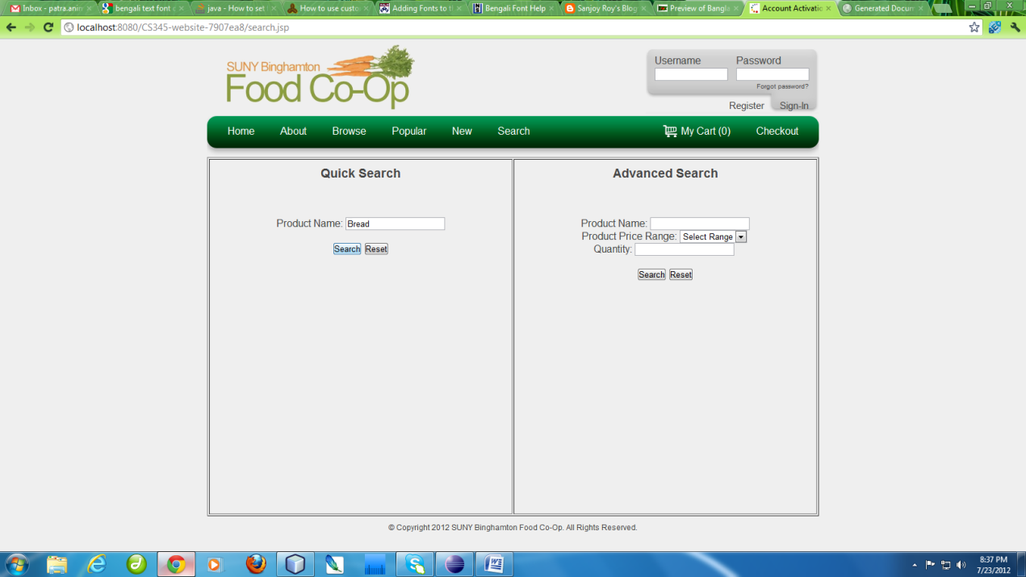

Output will be

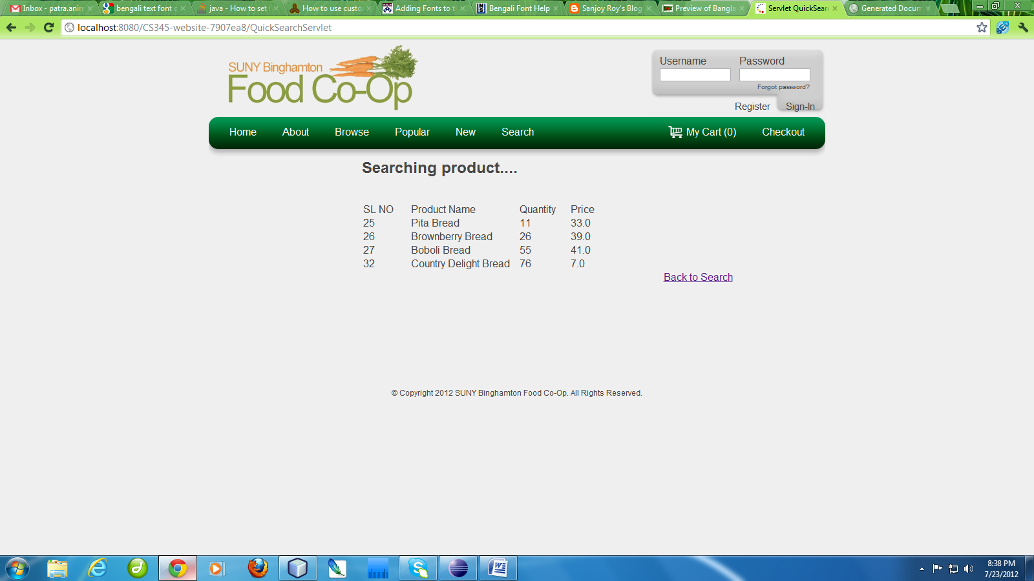

1. **For Advanced Search:-**

Product will search according to parameter like product price, quantity of product in database.

If you entered only keyword of product name, then searching will be similar to quick search.

**Example1:-** When we enter keyword ‘Bread’ with parameter like price less than 10$ and quantity 5. Then we get product which have name Bread and price less than 10$ and quantity in stock greater than 5 will be shown

